ML algorithms

# Algorithm

Fig. 1 shows the algorithm. The total amount of data is 80000. The data is divided in 20 beans, each of which has 4000 pieces of data. We discussed that first, before implementing the Gaussian process, implement the data, which has the energy as the output, and see how many data is good for the gaussian process. After that, I have implemented the gaussian, but I am not sure what to exactly show in the results. I should discuss it with you.

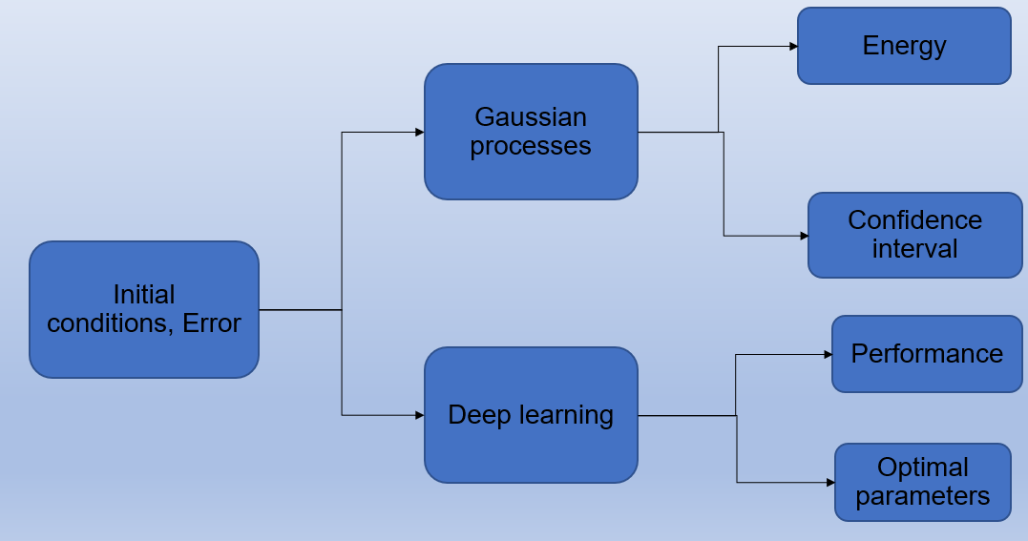

Figure

# Results

# The inputs are 3 Euler angles, 3 angular velocities, and error. The output is energy.



Figure . This figure represents the MAPE versus the number of layers for 80000 data. The inputs are 3 Euler angles, 3 angular velocities, and error. The output is energy



Figure . This figure represents the MAPE versus the amount of data for 10 layers. The inputs are 3 Euler angles, 3 angular velocities, and error. The output is energy. The quantity of data changes from 4000 to 80000



Figure . This figure represents the MAPE versus the number of neurons for 80000 data. The inputs are 3 Euler angles, 3 angular velocities, and error. The output is energy



Figure . This figure represents the MAPE versus the amount of data for 160 neurons. The inputs are 3 Euler angles, 3 angular velocities, and error. The output is energy. The quantity of data changes from 4000 to 80000

# The inputs are 3 Euler angles, 3 angular velocities, and error. The outputs are the controller parameters and the time of the development phase

The results are similar to the previous section so far. It is still running, and I will send the results by tomorrow morning.